
Coggeshall Catering Company

Weddings & Events
2024 brochure

07940561016
bookings@CoggeshallCateringCompany.co.uk
www.CoggeshallCateringCompany.co.uk

Welcome
We are a family run catering company based in beautiful Coggeshall, Essex, adjacent to Marks Hall Estate. We have a well-established history of event catering with over 15 years of experience, catering for intimate fine dining events to large weddings and corporate functions. Having catered many weddings in many different venues and settings we have an in-depth knowledge, so are well placed to guide you on planning the perfect day.

Why choose us?
Our team is led by highly experienced chef Adam and his wife Sarah who are both passionate about providing first rate service and food to their customers. Adam and Sarah themselves first met whilst running their respective wedding businesses at a local venue.
We are very passionate about the environment around us and do all we can to minimise our carbon footprint as well as using the finest, local sustainable produce as much as possible.

Our food
We make our dishes from scratch using the best ingredients and we pride ourselves on our ability to cater for all dietary requirements. Most of our dishes can be tailored to suit any requirements that are needed by you and your guests on your special day ensuring no one goes without a fabulous meal.
Whether you choose from our set menus or would like us to tailor make a bespoke menu, you can be assured that our experience will fulfil your requirements to make your day one to remember!

Our prices
We aim to give our customers excellent value for money and appreciate that every individual has a budget, so we like to work with you to find the best catering option for your wedding or event.

Our packages
All our 3 course menus and wedding packages include crockery, cutlery, waiting staff, kitchen staff, standard white table linen and a tea and coffee station.
Our wedding packages include a 3-course meal, 4 different canapes per person and an evening food option from only
We can offer a range of less traditional options should you want something more original such as grazing platters, tapas, barbecue, our mobile street food kitchen, our pizza horse box, hog roast, bowl food served and a range of hot and cold buffets. We can tailor the perfect package for your day.

Free Tastings
We recommend a tasting of some different food options dependent on your theme. This can take place at your venue (venue dependent) or our catering unit. These tastings are complimentary if a booking is made. Please contact us to arrange a tasting date.

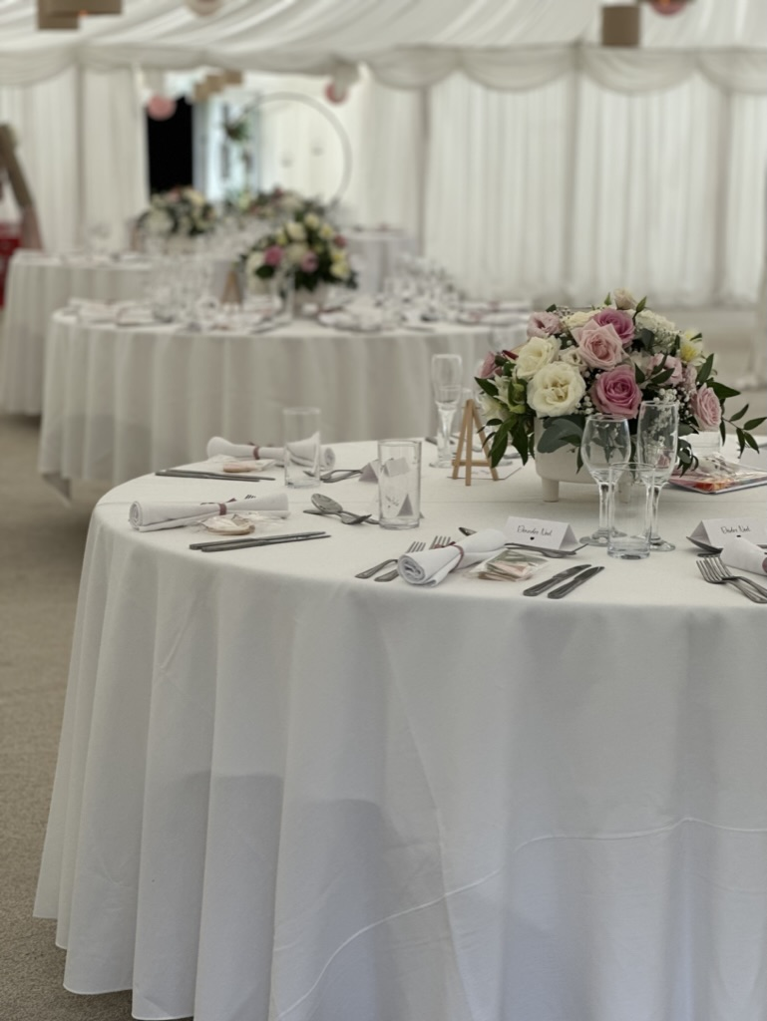

Our menus

Canapés

Served hot
Mini Yorkshire Puddings with Roast Beef and Horseradish
Garlic and Chilli Butter fried Tiger Prawns
Spiced Baby Sausages with mild Mustard Dip
Mini Chicken Satay with Sweet Chilli Dip
Baby Jacket Potato and Sour Cream (V)**
Caramelised Red Onion and Goats Cheese Tart (V)**
Scallops Wrapped in Bacon
Salmon Skewers with Lime Marinade
Wild Mushroom Fricassee Tart (V)**

Served Cold
Crouton topped with Smoked Duck and Oriental Sauce
Bruschetta topped with Tapenade and Roasted Cherry Tomato (V)*
Salmon Gravadlax with a Dill and Lemon dip
Mozzarella, Cherry Tomato and Basil Skewer (V)**
Toasted Brioche with Duck Liver Parfait
Lightly Roasted Bell Pepper filled with Cream Cheese and Chives (V)**
Mini Red Onion and Brie Quiche (V)**
Savoury Profiteroles with Spring Onion and Garlic Cream Filling (V)
Melon wrapped in parma ham
Grilled courgette topped with tomato relish (V)*
Crouton with houmous & toasted red pepper (V)*

Sweet Canapes
Chocolate Brownie Bites (V)**
Strawberries Dipped in Chocolate (V)*
Fresh Fruit Skewers with a Raspberry Cream Dip (V)**
Raspberry Mousse Tart (V)
Mini sweet scone with clotted cream and jam (V)**

(V) Vegetarian * Vegan ** Vegan version available
Please talk to us about special dietary requirements and food intolerances

Starters
Mixed breads and butter on the table

Tier 1
Roast plum tomato & basil soup (V)*
Sweet potato, chilli, ginger & coriander soup (V)*
Traditional prawn cocktail with Marie Rose sauce and little gem leaves
Torched goats’ cheese with beetroot & crisp salad (V)
Rolled chicken ballotine with tarragon dressing & baby leaves
Duck liver & orange pate with red onion chutney & ciabatta crostini
Red onion & brie tart with dressed baby leaves (V)
Smoked haddock & spinach fishcakes with lemon mayonnaise

Tier 2
Skewered chicken breast with mango, chilli & coriander salsa
Sweet chilli & garlic king prawn skewers on a bed of watercress
Melon & Parma ham with mozzarella pearls and truffle oil
Smoked salmon with lemon aioli & melba toast
Baked plum tomato with buffalo mozzarella, balsamic syrup & rocket (V)
Spiced & breaded chickpea cake with sweet tomato coulis (V)*

Sharing platters
Anti pasti – A variety of cured meats, olives, mozzarella pearls, roasted red pepper, baby gherkins, houmous, crusty bread & dressed leaves
Seafood platter – smoked salmon, beetroot gravadlax, sweet chilli prawn skewers, Thai fishcakes, lemon & smoked paprika mayonnaise & crusty granary bread

(V) Vegetarian * Vegan
Please talk to us about special dietary requirements and food intolerances

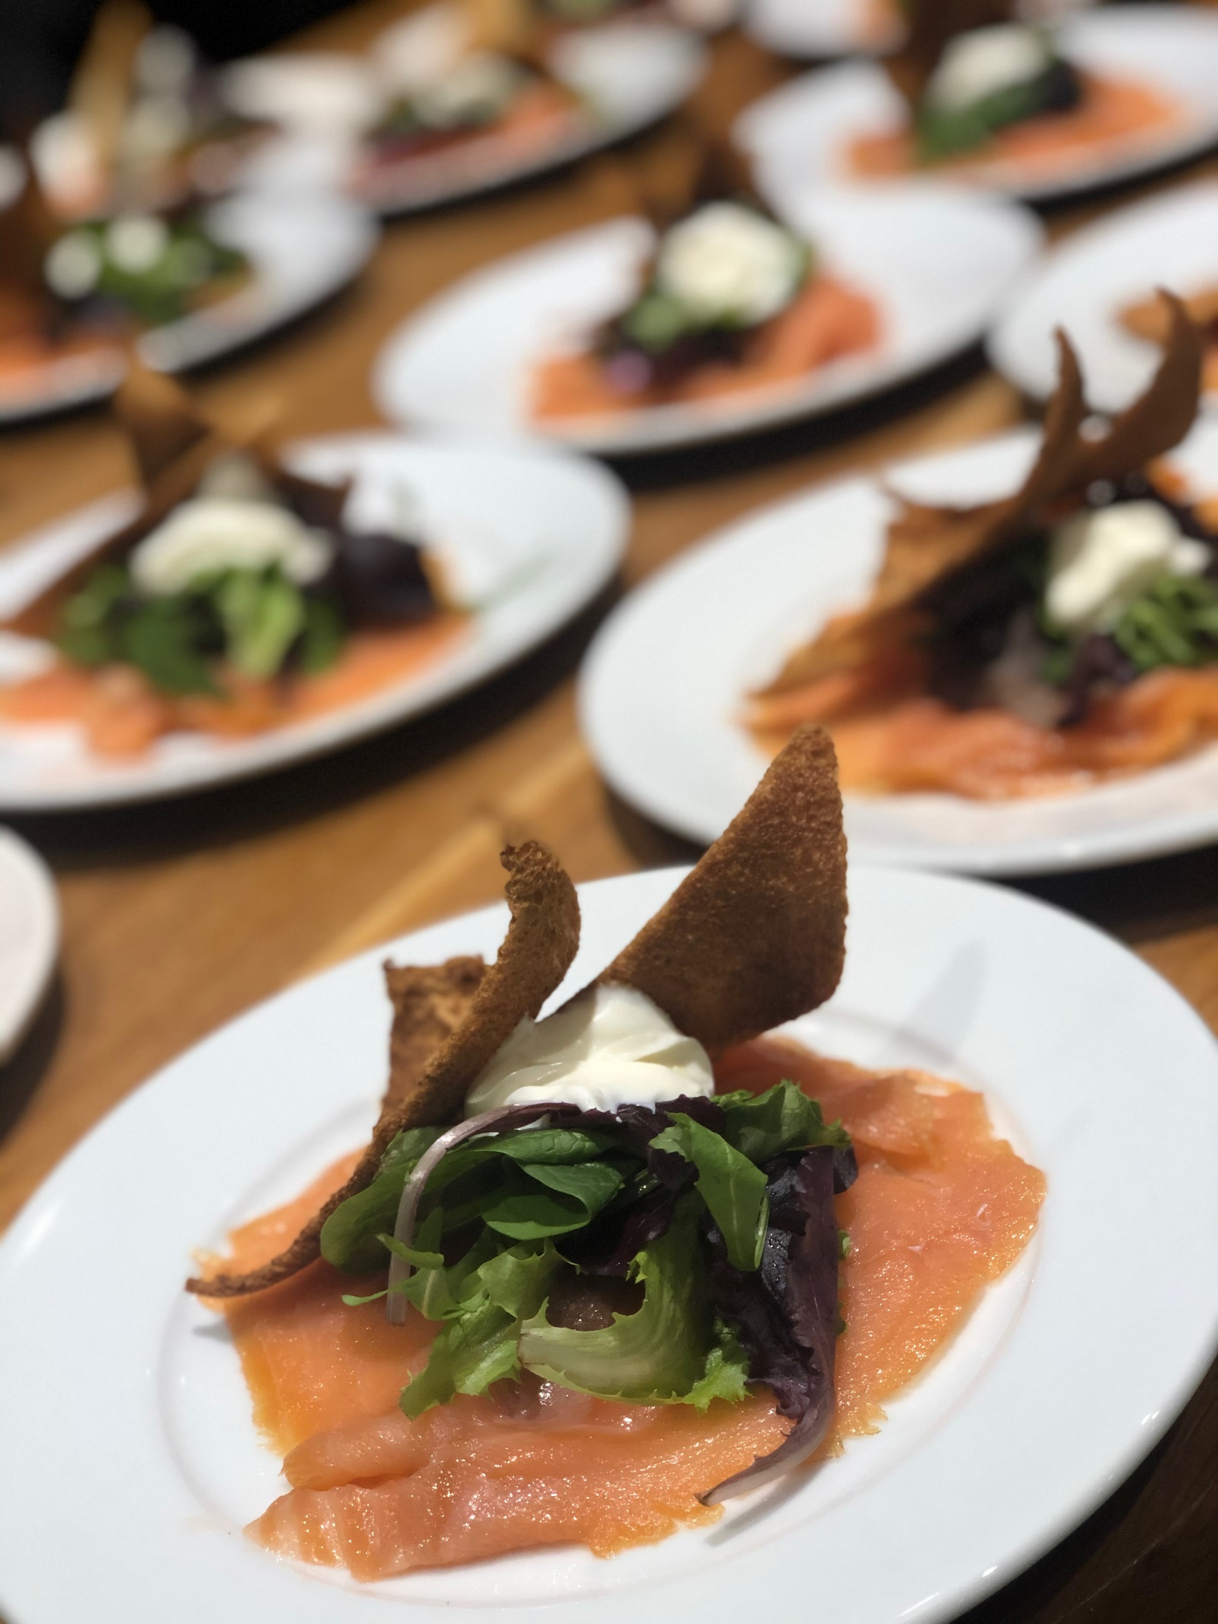

Mains

Tier 1
Pan fried chicken breast with creamy thyme & wild mushroom sauce
Confit duck leg with redcurrant jus
Slow roasted belly of pork with sage & apple jus
Steak & kidney pie with red wine jus
Chicken & mushroom pie with creamy thyme sauce
Roast chicken supreme with Yorkshire pudding, sausage meat stuffing and rich gravy
Pan fried seabass fillet with braised pak choi
Roast butternut squash filled with wild rice, baby spinach & smoked cheese (V)*
Portobello mushroom & roasted vegetable wellington with creamy thyme sauce (V)*

Tier 2
Pan fried salmon fillet with wilted spinach & lemon cream sauce
Slow roasted shoulder of lamb with Yorkshire pudding and rosemary jus
Filo basket with garlic braised wild mushrooms & truffle oil (V)*

Tier 3
Pan roasted lamb rump with minted squash puree & rosemary jus
Roasted ribeye of beef with Yorkshire pudding & red wine jus

All of our main courses are served with seasonal vegetables and your choices of potato dishes..
Roast potatoes
Creamy mashed potato
Minted new potato
Gratin dauphinois
Boulangère
Herb roasted new potatoes

Please talk to us about our variety of children’s options

(V) Vegetarian * Vegan
Please talk to us about special dietary requirements and food intolerances

Desserts
All desserts are handmade in house

Cold desserts
Lemon tart
Raspberry and White chocolate cheesecake
Biscoff Cheesecake
Mango and Passionfruit Pannacotta
Chocolate and salted caramel tart
Banoffee Pie
Brandy snap basket filled with Strawberry mousse
Tiramisu
Fresh seasonal fruit salad

Hot desserts
Spiced apple & berry crumble with vanilla pod custard
Sticky toffee pudding with toffee sauce
Rich chocolate brownie, raspberry coulis & cream

Trio of desserts
Three mini desserts, please choose any 3 of our dessert options

Cheese platter
A selection of 3 cheeses, red onion chutney, crackers & grapes

Sweet canape platter -
Please choose 4 different options from our sweet canapes

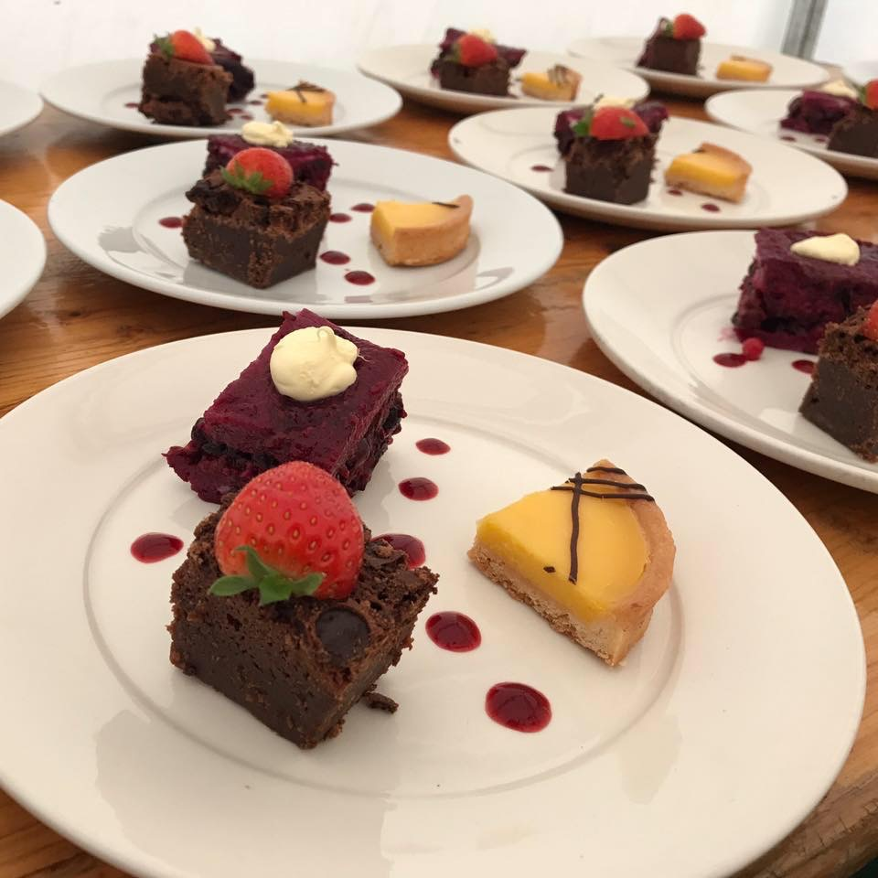

Barbeques & Hog Roasts

Family service available
All served with cheese and bread rolls

Barbeque tier 1
Homemade beef burgers
Directors sausages
Pepper & halloumi kebabs (V)**
Potato salad with chives & crème fraiche (V)
Mixed leaf salad (V)*
Green pesto pasta salad with cherry tomatoes (V)**
Red cabbage coleslaw (V)

Barbeque tier 2
Mains (choose 6) Sides (choose 5)
Beef minute steaks Potato salad with chives & crème fraiche (V)**
Directors sausages Mixed leaf salad (V)*
Cajun infused chicken drumsticks Green pesto pasta salad with cherry tomatoes(V)*
Portobello mushrooms filled with gorgonzola (V) Red cabbage coleslaw (V)
Homemade beef burgers Herb roasted baby potatoes (V)*
Pepper & halloumi kebabs (V)** Couscous & roast Italian vegetables (V)*
Minted lamb burgers Jacket potatoes (V)*
Spicy chicken strips Greek salad (V)**
Grilled halloumi steaks (V) Plum tomato, red onion & basil salad (V)*
Seasoned pulled pork
Hoi Sin glazed salmon

Hog roast
Whole hog spit roasted with crackling
Vegetarian quiche or vegetable & halloumi kebabs (V)**
Bread rolls (V)**
Apple sauce (V)*
Sage & onion stuffing
Red cabbage coleslaw (V)
Baby leaf salad (V)*

(V) Vegetarian * Vegan ** Vegan version available
Please talk to us about special dietary requirements and food intolerances

Afternoon tea

Finger Sandwiches (choose 3)
Egg mayonnaise and cress, Smoked salmon, Ham and mustard, Cucumber and cream cheese, Prawn mayonnaise, Cheddar & chutney

Savoury Items (choose 2)
Homemade sausage rolls
Cheese sable biscuits
Cheese scones
Pork pies
Brie & red onion tartlets

Sweet Items
Sweet scones with sultanas, jam & clotted cream
Rich Belgium chocolate brownie
Victoria sponge with raspberry jam and fresh cream

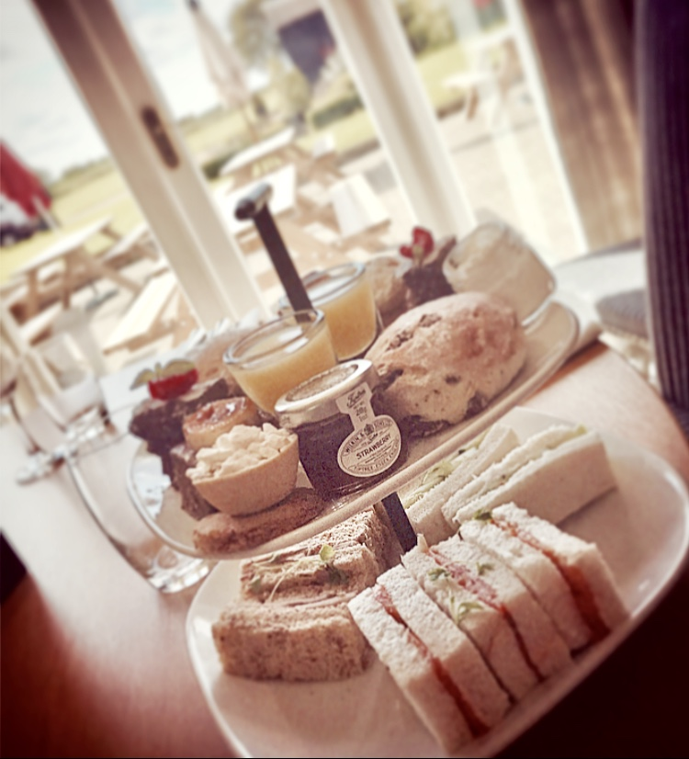

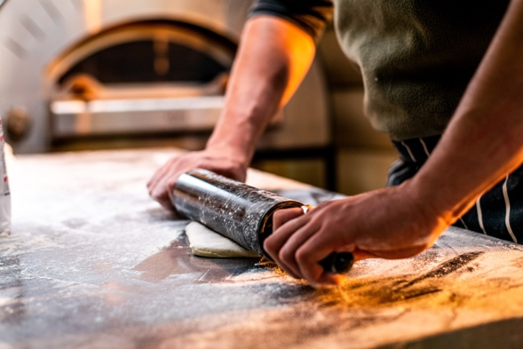
Evening Options

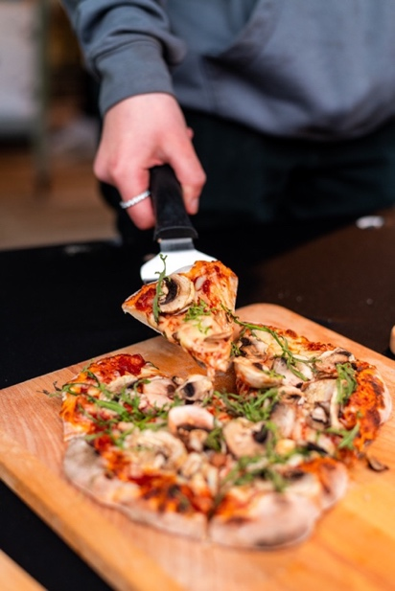
Pizza buffet from our horse box
Hand made stone baked pizzas baked in our large pizza oven housed in our vintage horse-box. Can be served with accompanying salads.

Hot Jacket Potatoes with a variety of toppings

Hot rolls
A selection of bacon and/or sausage rolls with French fries

Street food from our mobile street food kitchen (new for 2024)
A huge variety of different street food options available served from our mobile street food kitchen trailer. (Please enquire)

Hog Roast
Whole roasted hog and vegetarian option with all the accompaniments

Bowl Food – served to guests
Mini fish & chips with tartar sauce
Chorizo sausage & sable potato
Sausage & creamy mash with red onion jus
Beef or chickpea chilli with rice (V)**
Minted lamb casserole with creamy mash
Roasted Mediterranean vegetables & tomato coulis (V)*
Thai chicken or vegetable curry & rice (V)**
Chicken Caesar salad
Greek salad with feta cheese & olives (V)
Lemon infused tuna steak on baby spinach
Grilled goats cheese & cherry tomato salad (V)
Beef or vegetable lasagne (V)**
Melon & Parma ham salad
Barbecue
Barbecue tier 1 option

Cheese & Meat Buffet
A selection cheeses with chutney, pickles, crackers and grapes, sliced glazed ham, rare roast beef & a selection of breads

Cold Buffet
French breads & butter
Rare roasted topside of beef with horseradish sauce
Honey glazed ham on the bone with English mustard
Smoked salmon with lemon cream sauce
Glazed baby sausages
Vegetarian quiche (V)
New potato & chive salad (V)
Mixed leaf salad with honey & mustard dressing (V)*
Coleslaw (V)
Tomato & mozzarella salad with red onion & basil (V)*

